CS7637: Knowledge-Based AI:

RPM Milestone 1

Yaxin Yang

Yyang894@gatech.edu

***Abstract—*** This paper is divided into three main sections. First, it outlines the methodologies used to approach three problems found in Raven's test. Second, it delves into the specific architecture of the proposed agent designed to tackle these problems. Finally, it discusses the major challenges encountered in designing this agent.

# 1 PROBLEMS AND APPROACHES

## 1.1 Problem 1 - Basic Problem B-03

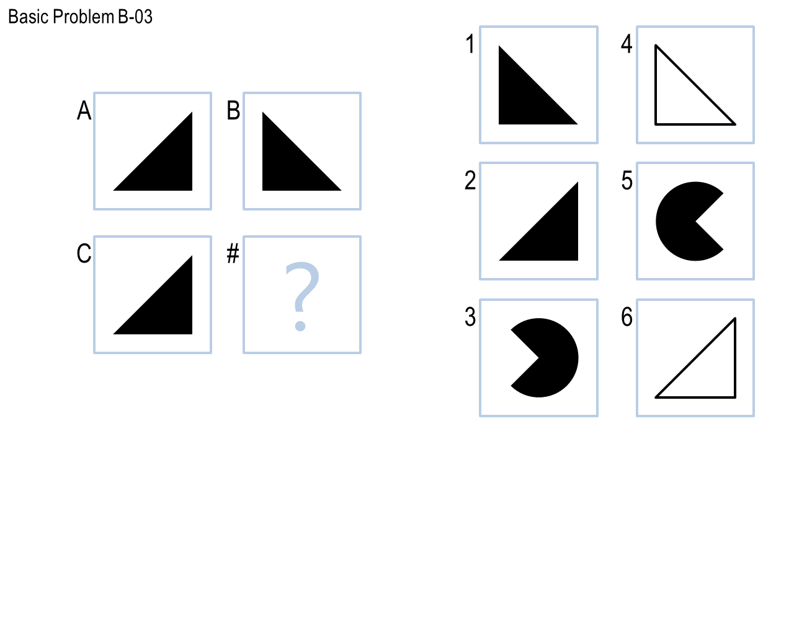

***Figure 1 —*** Basic Problem B-03, from Basic Problems B folder.

1) In this problem, figure B appears to be a reflection of figure A along a vertical axis situated equidistantly between them. By employing the same logic, a vertical axis can be imagined between figure C and D. Upon reflecting figure C across this vertical axis, the result is consistent with Answer Choice 1.

2) Figure B can alternatively be interpreted as either a 90-degree clockwise rotation or a 180-degree anticlockwise rotation of figure A. Applying the same transformation to figure C leads to an outcome that also corresponds to Answer Choice 1.

## 1.2 Problem 2 - Basic Problem D-08

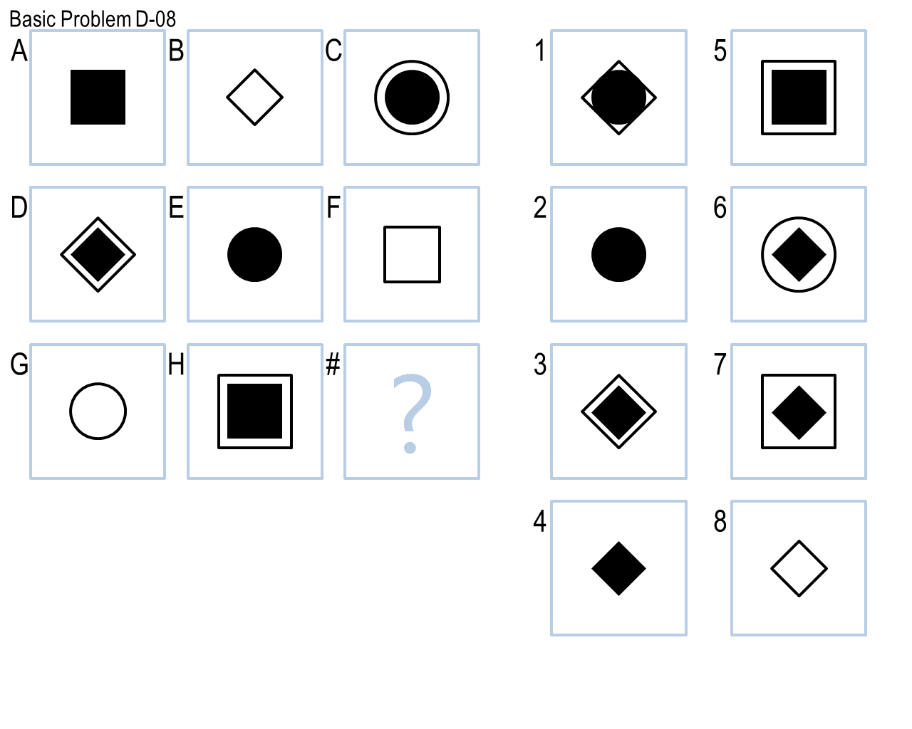

***Figure 2 —*** Basic Problem D-08, from Basic Problems D folder.

1) Initially, I observe that the first two rows each contain three unique shapes: a square, a diamond, and a circle. Based on this pattern, I would anticipate that the missing shape should be a diamond. Additionally, each row exhibits three distinct filling styles for the shapes: 1) entirely filled with black, 2) filled with white, and 3) containing a smaller shape of the same type, filled with black. Applying this pattern to think of the characteristics of the missing shape leads me to conclude that it should be a diamond entirely filled with black. Choice 4 aligns perfectly with this idea.

2) When considering the charts from figures A to I as a combined set, three shapes filled with white, and three shapes featuring a smaller, black-filled version of the same shape, are observed. This leaves room for three shapes to be filled with black. Upon further examination, each set of three shapes contains unique figures. Therefore, a black-filled diamond is needed to complete the pattern. Again, Choice 4 appears to be the appropriate answer.

## 1.3 Problem 3 - Challenge Problem B-05

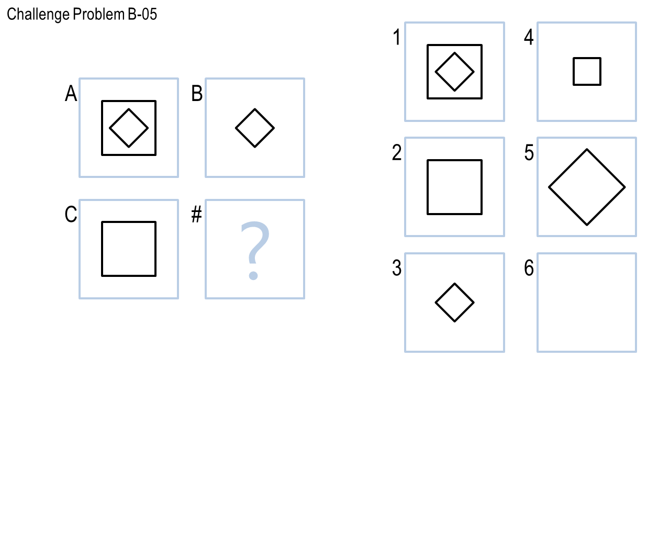

***Figure 3 —*** Challenge Problem B-05, from Challenge Problems B folder.

1) In the horizontal comparison, Figure B appears to be derived from Figure A by eliminating the outer shape, leaving only the inner diamond. Following this logic, if I were to remove the outer shape of Figure C, nothing remains. Consequently, the answer is 6, which is blank.

2) When viewed vertically, from Figure A to Figure C, the inner diamond is removed, leaving only the outer square. Extending this pattern from Figure B to the hypothetical Figure D, removing the inner diamond while retaining the outer shape would result in a blank space. Thus, the answer would also be a blank figure, number 6.

# 2 HOW WILL I DESIGN THE AGENT

## 2.1 Verbal representation

In designing my agent, I will employ knowledge representation techniques, specifically using semantic networks. The first step involves representing all objects present in the input figures. The second step entails adding labeled links among these objects to denote their relationships, such as 'above,' 'inside,' and 'top-right.' The third step involves analyzing the inputs—whether from a 2x2 or 3x3 Raven's test—to add transformation information. This will be done by creating additional labeled links that describe changes between objects, using terms like 'deleted,' 'unchanged,' or 'expanded.'

After constructing this semantic network, which captures the relevant information, the agent will then apply the same representation strategy to the figures in the last row. The objective is to generate the expected answer. If this answer is among the available choices, the agent will deem the Raven's test as solved. Alternatively, the agent could populate the last row by testing all possible answer choices and then selecting the one that most closely aligns with the previously established representations. This will serve as the final answer.

## 2.2 Heuristic methods

In addition to semantic networks, I plan to incorporate heuristic methods into the design of my agent. As discussed in the context of "Problem 1 - Basic Problem B-3," the agent can track various attributes such as changes in the number of specific shapes, both vertically and horizontally. It can also monitor shifts in distance and rotations in degrees. These heuristics can serve as auxiliary decision-making tools.

Similarly, in "Problem 2 - Basic Problem D-08," the agent could employ quantitative measures like calculating the number of darkened pixels or evaluating the ratio of darkened areas within a shape. These metrics can be invaluable for making more accurate decisions. By combining heuristic methods with a semantic network-based knowledge representation, the agent can benefit from both symbolic and quantitative reasoning. This hybrid approach aims to maximize the agent's problem-solving capabilities on Raven's tests.

## 2.3 Decision between strategies

As previously noted, multiple approaches can often be applied to the same Raven's test. Ideally, the agent will first generate potential answers using various methods. It will then compare these outcomes both with each other and with the available choices in the test. If all methods yield the same result, the agent can confidently conclude that the test has been solved. If produces different results, the agent will then need to evaluate which method to pick.

It's worth noting that complications may arise even when employing a single strategy. For example, as seen in Problem 1, the agent may need to decide between a reflection and a rotation if different outcomes are reached through these transformations. In such instances, a weighted decision-making process can be useful. The agent could assign points to different transformations, and then make a final choice based on the highest accumulated score.

# 3 CHALLENGES DURING DESIGN

Vocabulary limitations in semantic networks: The first challenge lies in constructing a sufficiently rich vocabulary to describe the relationships among objects within a semantic network. A failure of this could hold back the agent's ability to adequately understand the input, therefore affecting its ability to identify the correct answer.

Ranking complexity in large networks: the second challenge arises when the semantic network becomes large and complex, with numerous nodes and relationships. Determining which relationships are more critical than others. The agent needs to prioritize certain relationships over others to make effective decisions, but how it should do this remains an open question.

Efficiency: The third challenge refers to improving the agent's performance. Should adjustments be made on a case-by-case basis, or is there a more efficient, overarching method to enhance its general problem-solving capabilities? Fine-tuning the agent for specific scenarios may not be as productive as discovering generalized strategies that boost its overall "intelligence."

As I continue to study this course, I expect to gain further insights into these challenges and potentially discover new ones. The aim is to progressively refine the agent's design, enabling it to adapt and succeed in a broader scenario.